MINUTES
Prince of Wales North – School Council
October 22, 2019

In Attendance
Jennifer Currie, Wendy Fudge, Cindy Disher, Amy Whitaker, Anne McDonald
Absent: Mariel Hatrick, Anne Potter

Review of Minutes
No review at this time.

Principal’s Report
Principal Jennifer Currie presented her report.
Progress Reports and Parent Interviews
- Reports go home November 7th
- All parents will have the opportunity to have and interview by phone or in person
  - Individual Education Plans (IEP) went out last week
EQAO
- Extremely happy with the results.
Results

GRADE 3 GRADE 6
School Province School Province
Reading | 85% | 74% | 75% | 81%
Writing | 93% | 69% | 88% | 82%
Math | 78% | 58% | 56% | 42%

When asked how they were feeling the response from students was as follows:
Grade 3
  - 94% like Math
  - 89% feel like they are good in math
  - 81% feel like they are able to do difficult problems in Math
Grade 6
  - 88% like Math
  - 75% feel like they are good in math
  - 87% feel like they are able to do difficult problems in Math

- There tends to be a gap at Grade 4-5 and this is the reason for the change in results at Grade 6
- Learning Plans – Math Focussed

Levelled Literacy Intervention (continuing)
- Program that starts near the end of Grade 1 into 2 – Students are pulled for one on one reading base on their reading level and skill set.
Attendance Counselor Presentation – Nov.26 at 5:30 pm (before council meeting)
- There are some students missing a lot of school
- Presentation will give suggestions and help to parents to encourage attending school.
Social Worker Support – Thursdays at 2:30pm in the Learning Commons - Starting Nov. 14th
- The school social worker will be available to answer questions and give guidance to parents
  - ie. Don’t’ have a doctor – how do I find one?, child with anxiety, etc.
DSBN Academy – Parent Information Schedule
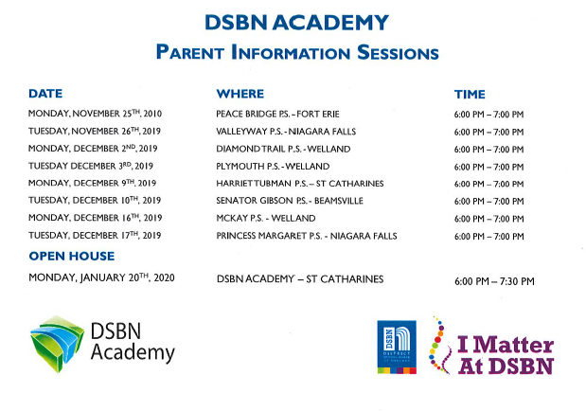
Chocolate Bar Fundraiser
- To be held in the spring
- More details to follow.

Parent Involvement Council (PIC) Conference
- November 6, 2019 from 4:00PM to 8:15pm at Eden High School
- Free conference for parents – Registration required to attend. Features: informative workshops, vendor resource fair and light dinner. Child care avail. by pre-registration.

Important Dates
- Halloween Thursday, October 31 – Parade around the school yard at 9:30 am (weather permitting)
  - Intermediate students set up activities in the gym for younger students to participate in during the day.
  - Older students will have dance in the afternoon
- Remembrance Day Assembly – Monday, November 11 at 10:00 am – all welcome

Next Meeting
Next School Council meeting will be held on November 26 at 6:00 PM (following Attendance Counselor session).
Council meeting are held on the 4th Tuesday or the month.
Please note: there will not be a council meeting in December or June

